|  |  |
| --- | --- |
| Semester | T.E. Semester VI – Computer Engineering |
| Subject | Cloud Computing |
| Subject Professor In-charge | Prof. Divya Nimbalkar |
| Assisting Teachers | Prof. Divya Nimbalkar |

|  |  |
| --- | --- |
| Student Name | Deep Salunkhe |
| Roll Number | 21102A0014 |
| TE Division | A |

**Title: PBLE 2 Video transcript generation.**

**Explanation:**

**1. Amazon Simple Storage Service (S3):**

* **Purpose:** Amazon S3 is a scalable object storage service designed to store and retrieve any amount of data from anywhere on the web.
* **Key Features:**
  + **Scalability:** S3 automatically scales to accommodate growing data needs, making it suitable for a wide range of applications.
  + **Durability:** S3 is designed for 99.999999999% (11 nines) durability, ensuring data remains intact and accessible over time.
  + **Security:** S3 provides robust security features, including encryption, access control, and auditing, to protect stored data.
  + **Data Management:** S3 offers features for managing data lifecycle, versioning, replication, and access control policies.
  + **Integration:** S3 integrates seamlessly with other AWS services, enabling developers to build scalable and reliable applications.
  + **Performance:** S3 offers high performance with low latency access to data, support for parallel uploads and downloads, and features like transfer acceleration.

**2. Amazon Transcribe:**

* **Purpose:** Amazon Transcribe is an automatic speech recognition (ASR) service that converts speech to text, allowing developers to transcribe audio and video files into readable text.
* **Key Features:**
  + **Speech Recognition:** Transcribe accurately transcribes spoken words into text, supporting a wide range of audio and video formats.
  + **Customization:** Users can customize vocabulary and language models to improve transcription accuracy for specific domains or accents.
  + **Timestamping:** Transcribe provides timestamps for each transcribed word, enabling users to correlate the text with the original audio/video content.
  + **Real-time Transcription:** Transcribe supports real-time streaming transcription for live audio streams, enabling applications like captioning and subtitling.
  + **Integration:** Transcribe seamlessly integrates with other AWS services, allowing developers to automate transcription workflows and analyze transcribed text using services like Amazon Comprehend.

**3. Amazon Translate:**

* **Purpose:** Amazon Translate is a neural machine translation service that provides fast and accurate translation of text between languages.
* **Key Features:**
  + **High-Quality Translation:** Translate leverages deep learning models to deliver high-quality translations across a wide range of languages.
  + **Custom Terminology:** Users can specify custom terminology to ensure accurate translation of domain-specific terms and phrases.
  + **Batch Translation:** Translate supports batch translation of large volumes of text, enabling efficient translation of documents, websites, and applications.
  + **Real-time Translation:** Translate offers real-time translation for interactive applications, enabling multilingual communication in chatbots, messaging apps, and more.
  + **Integration:** Translate integrates seamlessly with other AWS services, allowing developers to automate translation workflows and localize content for global audiences.
* **Steps to Generate Transcription using AWS S3 and Amazon Transcribe:**

1. **Upload Audio/Video File to S3**:
   * Upload the audio or video file that you want to transcribe to an S3 bucket. Make sure you have appropriate permissions to access the bucket and the file.
2. **Configure IAM Role**:
   * Create an IAM role with permissions to access the S3 bucket and interact with Amazon Transcribe. Assign appropriate policies to this role, such as **AmazonS3ReadOnlyAccess** and **AmazonTranscribeFullAccess**.
3. **Create Transcription Job**:
   * Go to the Amazon Transcribe console.
   * Click on "Create transcription job" and provide the necessary details:
     + Job name: A descriptive name for the transcription job.
     + Input file location: Specify the S3 URI of the input file (e.g., **s3://bucket-name/path/to/input/file.mp3**).
     + Output location: Optionally specify an S3 URI where you want to store the transcribed text output.
     + Language: Choose the language spoken in the audio/video file.
     + Settings: Configure additional settings such as vocabulary customization or speaker identification if needed.
   * Start the transcription job.
4. **Monitor Transcription Job**:
   * Monitor the progress of the transcription job in the Amazon Transcribe console. Depending on the size and complexity of the input file, it may take some time to complete.
5. **Access Transcription Output**:
   * Once the transcription job is complete, you can access the transcribed text output from the specified S3 output location or download it directly from the Amazon Transcribe console.

* **Steps for Translation:**

1. **Setup Amazon Translate**:
   * If you haven't already, enable the Amazon Translate service in your AWS account.
2. **Prepare Text for Translation**:
   * Take the transcribed text obtained from Amazon Transcribe and prepare it for translation. This may involve formatting the text or separating it into smaller segments if necessary.
3. **Create Translation Job**:
   * Go to the Amazon Translate console.
   * Click on "Translate text" and provide the following details:
     + Source language: The language of the original text (e.g., English).
     + Target language: The language into which you want to translate the text (e.g., Spanish).
     + Text to translate: Paste or upload the transcribed text that you want to translate.
   * Start the translation job.
4. **Monitor Translation Job**:
   * Monitor the progress of the translation job in the Amazon Translate console. Depending on the size of the text and the target language, it may take some time to complete.
5. **Access Translated Text**:
   * Once the translation job is complete, you can access the translated text output from the Amazon Translate console or download it directly.



**Implementation:**

* **S3:**

* **AWS Transcribe:**

* AWS Translate:

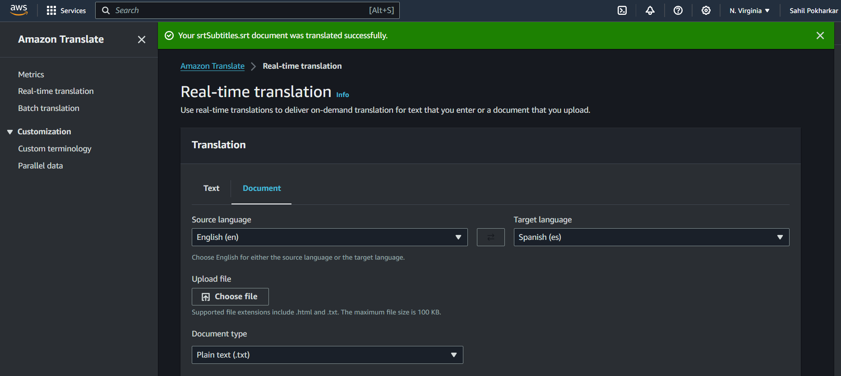

|  |
| --- |
|  |
|  |  |

**Conclusion:** Amazon S3 offers scalable, durable, and secure object storage, serving as the foundation for storing vast amounts of data in the cloud. Amazon Transcribe leverages advanced speech recognition technology to transcribe audio and video content into text accurately, enabling efficient analysis and accessibility. Meanwhile, Amazon Translate facilitates seamless translation of text between languages, empowering businesses to reach global audiences and break down language barriers. Together, these services form a powerful suite of tools for managing, transcribing, and translating multimedia content, driving innovation, and enabling cross-cultural communication in today's interconnected world. With their integration and versatility, AWS users can harness the full potential of their data and deliver impactful experiences to users worldwide.